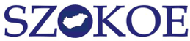 |  | 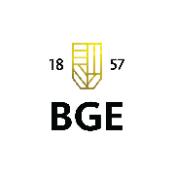

The Hungarian Association of Teachers and Researchers of

Languages for Specific Purposes (SZOKOE)
and the Institute of Foreign Languages and Communication at the Budapest Business School

cordially invite you to participate in

SZOKOE 17th annual International Conference

entitled

KNOWLEDGE SHARING, VALUE TRANSMISSION, DIGITALISATION – TRENDS IN TEACHING AND RESEARCHING LANGUAGES FOR SPECIFIC PURPOSES

17-18th November 2017

Budapest Business School
College of Commerce, Hospitality and Tourism
Department of Foreign Languages

Markó u. 29-31., 1055 Budapest, Hungary
Talks and poster presentations are invited in Hungarian and English in the following fields:

knowledge sharing, value transmission
educational technologies, digitalisation
terminology, lexicology
genre studies, discourse analysis
intercultural communication, translation, interpretation
curriculum, material design, methodology
assessment, evaluation, testing

SZOKOE is also inviting papers for Porta Lingua 2018.

Further information and registration:

https://uni-bge.hu/szokoe

