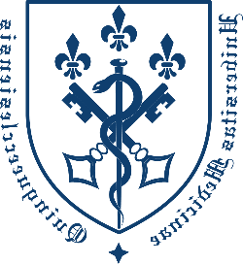
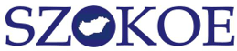
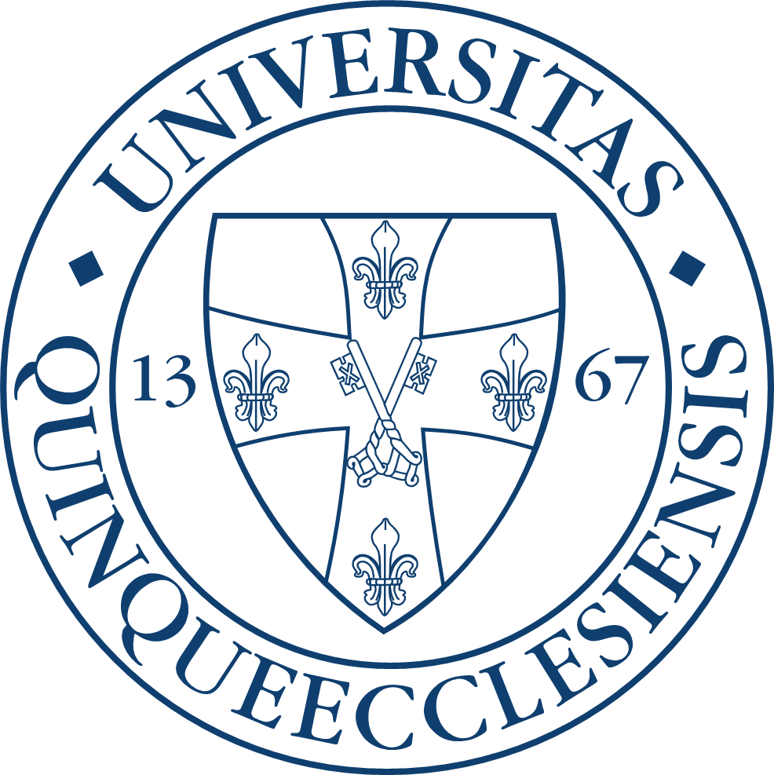
The Hungarian Association of Teachers and Researchers of
Languages for Specific Purposes (SZOKOE)
and the Department of Languages for Specific Purposes
at the Medical School of the University of Pécs

cordially invite you to participate in

SZOKOE 18th annual International Conference

entitled

Interdisciplinary Approaches in LSP Education and Research

Time and venue of the conference

9-10 November, 2018

Regional Centre of the Hungarian Academy of Sciences in Pécs

Jurisics M. u. 44. 7624-Pécs, Hungary
Talks and poster presentations are invited in Hungarian
and English in the following fields:

knowledge sharing, value transmission
educational technologies, digitalisation
terminology, lexicology
genre studies, discourse analysis
intercultural communication, translation, interpretation
curriculum, material design, methodology
assessment, evaluation, testing

SZOKOE is also inviting papers for Porta Lingua 2019

https://aok.pte.hu/egyseg/index/60/szokoe
Further information and registration: on 27.08.2018.

